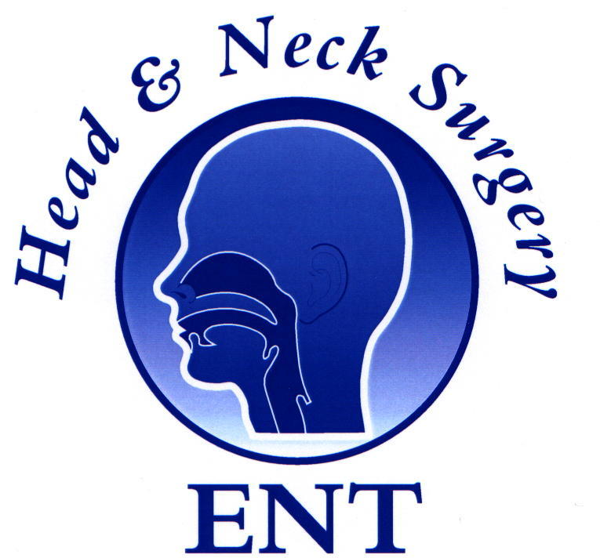
4th ENT Masterclass® ‘World Congress’

Proposed Course Programme
Palace of Parliament, Bucharest, Romania
31st Oct-1st Nov 2025

Day 1
08:00 Registration: Tea/Coffee

Inauguration
8:45 | Dr Mahmoud Daoud | Moderator
 | Prof Viorel Zainea, | Co-Chairmen Welcome
 | Prof Viorel Jinga, Rector | Inauguration
 | Prof Prof Razvan Hainrosie | President Romanian Society of ENT
 | Prof Shahed Quraishi OBE | Chairman ENT Masterclass®  ENT Masterclass® report
 | Session I: | Paediatric Otolaryngology
 | Paediatrics chair: | Prof Niculae Balica
9:30 | Eishaan Bhargava | The ‘snotty’ child TBC
9:50 | Michael Kuo | Management of Paediatric airway challenges
10:10 | Asad Qayyum | Paediatric Cholesteatomas: a structured approach
10:30 | Michael Kuo | Neck lumps in children: management strategies
10:50 | Dan Cristian Gheorghe | Cochlear implantation-routine or surgical challenge?
11:10 | Coffee
11:30 | Abir Bhattacharya | Discharging mastoid: current concepts
11:50 | Richard Irving | Management of the facial nerve in temporal bone fractures
12:10 | Shak Saeed | Management of Vestibular Schwannoma -emotional and other investments in decision making ?
12:30 | Emma Stapleton | Infections of the skull base

13:00 Lunch & Trade Exhibition

Session II: Otology
Otology chair: Prof Anghelina Florin
14:00 | Shak Saeed | Surgical videos: Masterclass in Otology
14:20 | Emma Stapleton | Current practice in Cochlear implantation
14:40 | Asad Qayyum | Management of retraction pockets
15:00 | Abir Bhattacharya | Intratympanic treatment for inner ear pathology
15:30 | Coffee
16:00 | Prof Alma Maniu | Tips and tricks in stapes surgery TBC
16:20 | Moderator: Mr Richard Irving | Otology panel

17:00 Finish

Day 2

Session III: Rhinology & Facial Plastics
Rhinology chair: Prof Raluca Grigore
8:30 | Shaz Ahmed | External Approaches to the Frontal Sinus
8:50 | Oliver Kaschke | Modern techniques in Rhino surgery
9:10 | Hesham Saleh | Top tips in Rhinoplasty surgery
9:30 | Razvan Hainarosie | The ENT surgeon in and around the orbit
9:50 | Hiba AlReefy | Artificial Intelligence (AI) in Rhinology TBC
10:10 | Claire Hopkins | Current opinions on olfactory dysfunction
10:30 | Sanofi sponsored talk  Razvan Hainarosie | Changing the treatment paradigm in CRSwNP TBC
10:45 | Coffee
11:00 | Claire Hopkins | Current opinion on Acute Rhinosinusitis
11:20 | Mahmoud Daoud | Masterclass on nasal valve surgery
11:40 | Shaz Ahmed | Assessment & Management of Facial pain
12:00 | Moderator: Hesham Saleh | Rhinology panel

13:00 Lunch & Trade Exhibition

Session IV: Head & Neck
Head and Neck chair: Prof Dragos Palade
14:00 | Oliver Kaschke | Navigation surgery: state of the art
14:20 | Richard Oakley | Management of the Unknown primary of the Head & Neck
14:40 | Coffee
15:10 | Viorel Zainea | Pre-malignant lesions and early cancer of the vocal fold TBC
15:30 | Guri Sandhu | Airway compromise from Thyroid disease
15:50 | Shayan Ansari | Challenges in Advanced Thyroid Malignancy
16:10 | Jai Manick | Lasers in Laryngeal surgery
16:30 | Richard Oakley | Updates in Oral Cavity cancer
16:50 | Guri Sandhu | Advances in Laryngotracheal surgery
17:10 | Moderator: Richard Oakley | Head & neck panel

18:00 Finish

Faculty Members:

- Mr Michael Kuo (UK)
- Prof Dan Cristian Gheorghe (Romania)
- Mr Asad Qayyum (UK)
- Miss Emma Stapleton (UK)
- Mr Rihard Irving (UK)
- Mr Abir Battacharya (UK)
- Prof Shak Saeed (UK)
- Prof Alma Maniu (Romania)
- Prof Oliver Kaschke (Germany) 1st Nov only
- Prof Hesham Saleh (UK)
- Prof Claire Hopkins (UK)
- Dr Hiba AlReefy (Bahrain)
- Mr Shaz Ahmed (UK) +1
- Razvan Hainarosie (Romania)
- Dr Mahmoud Daoud (Romania)
- Prof Viorel Zainea (Romania)
- Mr Richard Oakley (UK)
- Mr Jai Manick (UK)
- Prof Shayan Ansari (UAE)
- Prof Shahed Quraishi (UK)
- Prof Guri Sandhu (UK)+1

