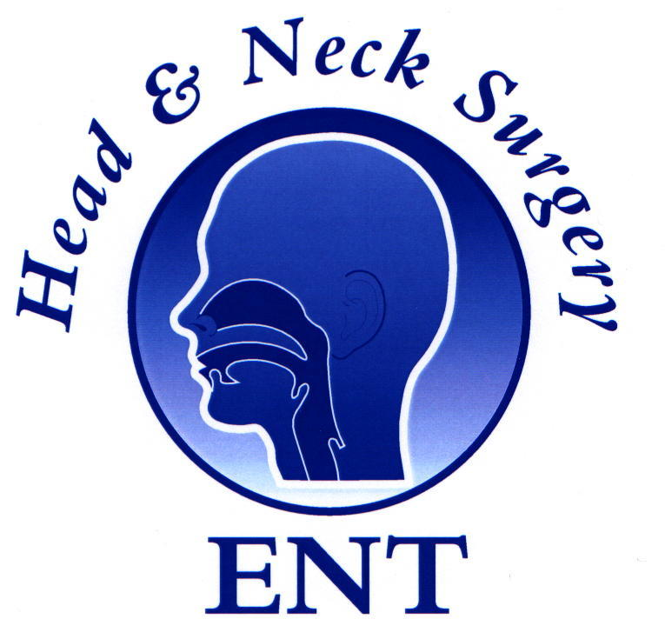
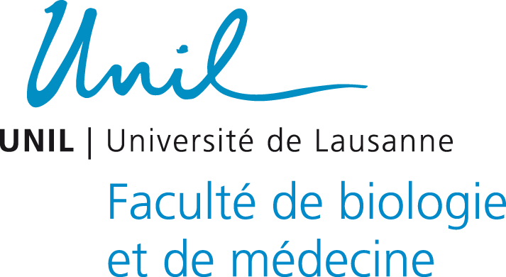


Application form
2nd Annual ENT Masterclass® ‘Switzerland’
Venue: Dept of ORL & chirurgie cervico-faciale
Centre Hospitalier Universitaire Vaudois (CHUV)
Av. Du Bugnon 46, CH-1011 Lausanne
8-9th Nov 2019

Please see instructions below

Hand written forms are not accepted

Name: _ ________________________________________________________________

Address: _ ______________________________________________________________

_______________________________________________________________

Qualifications with date: _________________________________________________

Job title: _________________________________________

Employing hospital: ____________________________________________

Country: ____________________________________________

E-mail Address: ___________________________________________

Date: ____________________

- Before emailing the form please make a non-refundable charge of 60 Euros or 50 Pound Sterling to cover catering costs and admin via bank transfer.
- Please ensure you put your name as reference in the bank transfer.
- Incomplete or inaccurate forms will incur an admin charge of 20 Euros

Bank details for Pound sterling: Bank details for Euros:
ENT Masterclass ENT Masterclass Ltd
NatWest Bank, Nottingham University Branch. NatWest Bank
Sort code: 54 21 51 IBAN: GB54 NWBK 6072 0933 5061 16
Acct number: 30673046 Swift/BIC code: NWBKGB2L
IBAN GB20 NWBK 5421 5130 6730 46
Swift/BIC NWBK GB 2L

To secure your place, please fill this form electronically and attach it as a Word document to an email to entmasterclass@hotmail.com

along with confirmation of the bank transfer

