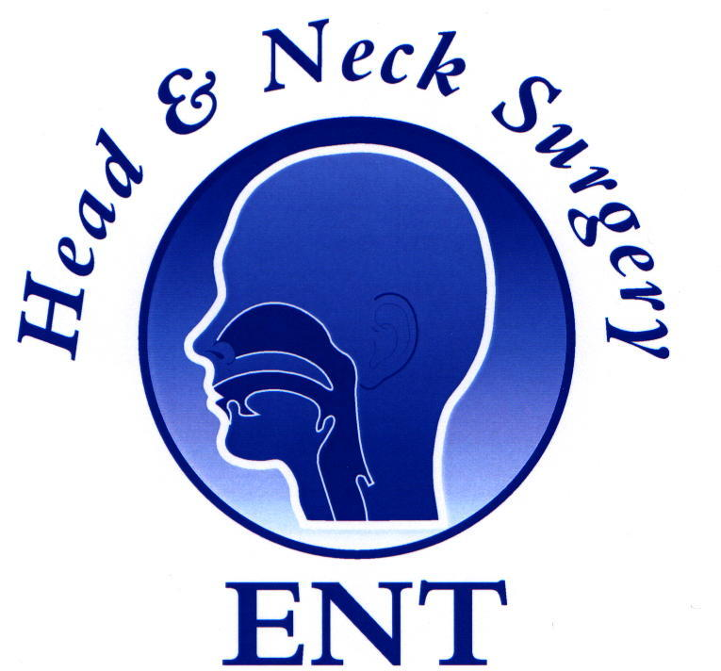
5th ENT Masterclass® ‘World Congress’

Proposed Course Programme
Palace of Parliament, Bucharest, Romania
30-31st Oct 2026

Day 1 08:00 Registration: Tea/Coffee

Inauguration
8:45 | Dr Mahmoud Daoud | Moderator
 | Prof Viorel Zainea, | Co-Chairmen Welcome
 | Prof Poiana Catalina | President, Romanian College of Doctors
 | Prof Razvan Hainarosie | President Romanian Society of ENT
 | Prof Shahed Quraishi OBE | Chairman ENT Masterclass®  ENT Masterclass® report
 | Session I: | Paediatric Otolaryngology
 | Paediatrics chair: | Prof Niculae Balica
09:40 | Michael Kuo | Paediatric airway challenges & solutions
10:00 | Asad Qayyum | How to avoid complications in Stapes Surgery
10:20 | Michael Kuo | Paediatric Neck lumps
10:40 | Dan Cristian Gheorghe | Acute mastoiditis in children - Dilemmas & management
11:10 | Coffee
11:30 | Abir Bhattacharya | Top tips in managing discharging mastoids.
11:50 | Richard Irving | Masterclass on Facial Nerve Palsy
12:10 | Jaydip Ray | Masterclass in Otological Implants
12:30 | Emma Stapleton | Infections of the skull base

13:00 Lunch & Trade Exhibition

Session II: Otology
Otology chair: Prof Anghelina Florin
14:00 | Jaydip Ray | Innovative management of balance disorders
14:20 | Emma Stapleton | Current practice in Cochlear implantation
14:40 | Asad Qayyum | Pearls and pitfalls in Ossiculoplasty
15:00 | Abir Bhattacharya | Intratympanic treatment for inner ear pathology
15:30 | Coffee
16:00 | Prof Alma Maniu | Beyond Disease Control: Hearing Reconstruction After Cholesteatoma Surgery
16:20 | Moderator: Mr Richard Irving | Otology panel

17:00 Finish

Day 2

Session III: Rhinology & Facial Plastics
Rhinology chair: Prof Raluca Grigore
9:00 | Shaz Ahmed | External Approaches to the Frontal Sinus
9:20 | Isma Iqbal | Complications in Sinus surgery
9:40 | Marlene Speth | Chronic rhinosinusitis and Biologics:
10:00 | Hesham Saleh | Top tips in Rhinoplasty surgery
10:20 | Razvan Hainarosie | The ENT surgeon in and around the orbit
10:50 | Coffee
11:20 | Sanofi sponsored talk  Razvan Hainarosie | “Freedom to Breathe: Transforming the Future of CRSwNP with Dupixent
11:40 | Mahmoud Daoud | Challenging septums in Rhinoplasty
12:00 | Shahz Ahmed | Management of Spontaneous Cerebrospinal Fluid Rhinorrhea
12:20 | Moderator: Hesham Saleh | Rhinology panel

13:00 Lunch & Trade Exhibition

Session IV: Head & Neck
Head and Neck chair: Prof Dragos Palade
14:00 | Richard Oakley | Management of the Unknown primary of the Head & Neck
14:20 | Viorel Zainea | Management of premalignant lesions and early cancer of the vocal fold
14:50 | Farhan Ahsan | Robotics in Head & Neck Surgery
15:10 | Coffee
15:40 | Keshav Gupta | QoL outcomes with Transoral Robotic Surgery
16:00 | Shayan Ansari | Challenges in Advanced Thyroid Malignancy
16:20 | Amit Prasai | Management of Lympho vascular Lesions in the Head and Neck
16:40 | Richard Oakley | Malignant salivary gland cancer management
17:00 | Moderator: Richard Oakley | Head & neck panel

18:00 Finish

Faculty Members:

- Mr Michael Kuo (UK)
- Prof Dan Cristian Gheorghe (Romania)
- Mr Asad Qayyum (UK)
- Miss Emma Stapleton (UK)
- Mr Richard Irving (UK)
- Mr Abir Battacharya (UK)
- Prof Jaydip Ray (UK)
- Prof Alma Maniu (Romania)
- Prof Hesham Saleh (UK)
- Ms Marlene Speth (Germany)
- Mr Shaz Ahmed (UK) +1
- Miss Isma Iqbal (UK)
- Razvan Hainarosie (Romania)
- Dr Mahmoud Daoud (Romania)
- Prof Viorel Zainea (Romania)
- Mr Richard Oakley (UK)
- Mr Amit Prasai (UK)
- Mr Keshav Gupta (UK)
- Prof Shayan Ansari (UAE)
- Mr Farhan Ahsan (UK)
- Prof Shahed Quraishi (UK)

