**4th ENT Masterclass® World Congress**

**31st Oct-1st Nov 2025**

**Palace of Parliament, Bucharest, Romania**

**International Faculty**

**Thirty lectures, 3 panel discussions. 14 hours CME credit**

*Paediatrics, Otology, Rhinology/facial plastics, Head & Neck Oncology.*

**Poster presentation:**

**6 ENT Masterclass research prizes**

**500 Euros each for the finalists**

<https://www.entmasterclass.com/ent-masterclass-world-congre>

**Deadline for submission: 10th Oct 2025**

Submission guidelines:

* Applicants must be in training grades/middle grades
* The paper should not have been published or presented at a national or international meeting previously
* Posters must be structured and submitted electronically in pdf format
* The presenting author’s full details including name, work address, email address and name of institution where the work took place must be given.
* All submissions should contain a statement of copyright permission and that all authors have agreed the contents of the paper for submission.
* **The presenting author must be registered for the event**

Please submit posters to: [entmasterclass@hotmail.com](mailto:entmasterclass@hotmail.com)

[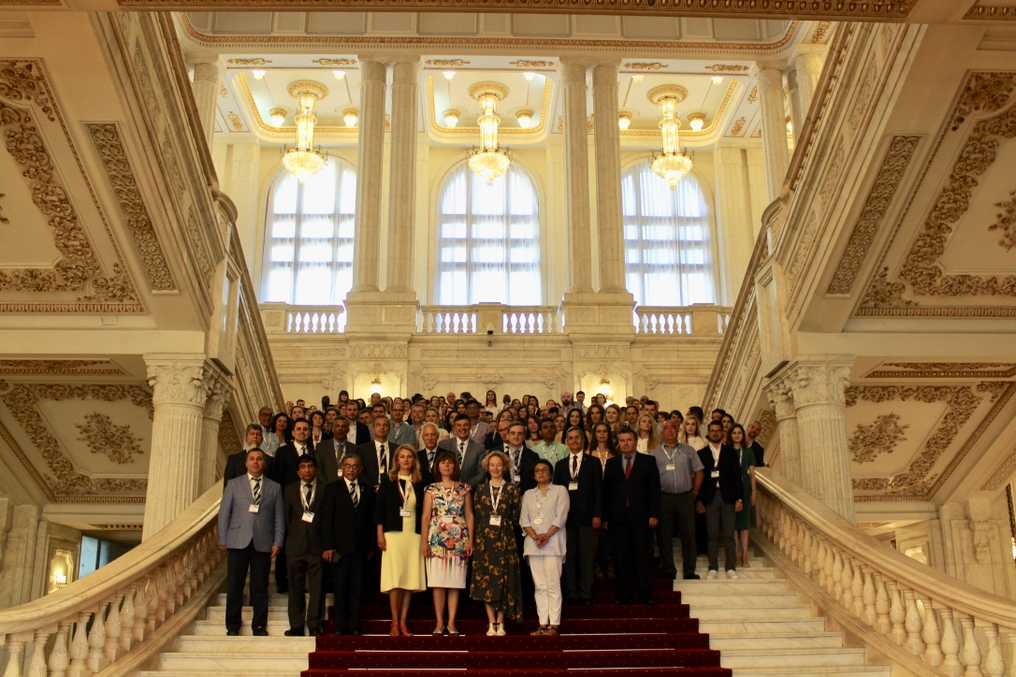](https://www.entmasterclass.com/ent-masterclass-world-congre)