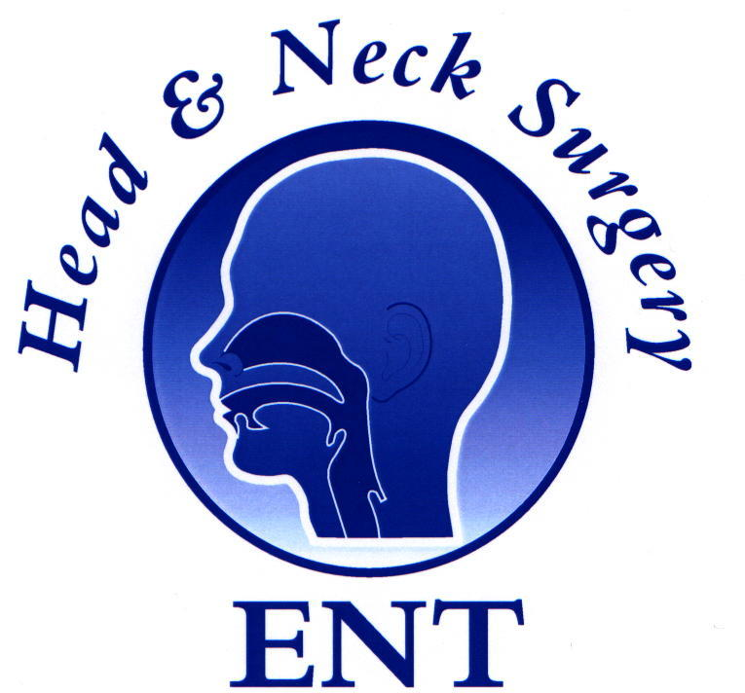**ENT Masterclass Program 9th—10th April 2016**

**(10th April programme in Blue)**

|  |  |  |
| --- | --- | --- |
| 0800-0810 | Welcome Introduction | CP |
| 0810-0840 | Snoring and Sleep Apnoea  **Sleep Apnoea Surgery** | Stuart Mackay/Lyndon Chan |
| 0840-0910 | Otitis Media  **Update on endoscopic ear surgery** | Dr Alex Saxby |
| 0910-0940 | Functional Rhinoplasty  **Nasal Valve Surgery** | Dr Narinder Singh |
| 0940-1010 | Sinus Surgery  **Skull base surgery** | Dr Richard Harvey |
| 1010-1030 | Morning Tea |  |
| 1030-1100 | Head and Neck Surgery  **TORS** | Dr Jonathan Clark |
| 1100-1130 | Hearing Loss & Implants  **Neonatal Screening** | Dr Cathy Birman |
| 1130-1200 | Acute and Chronic Sinusitis  **FESS and Complications** | Dr Larry Kalish |
| 1200-1230 | Paediatric ENT | Dr Alan Cheng |
| 1230-1300 | Acute ENT Emergencies  **Airway Emergencies** | Dr Mark Smith |
| 1300-1400 | Lunch and free papers |  |
| 1400-1800 | Skills Workshops   1. ENT Radiology 2. Airway Skills 3. ENT Emergencies 4. Pathways to ENT Training 5. Nasendoscopy | 1. Jeff Wang/Nin Sritharan 2. Akshay/Gerry Khong 3. Ron Chin/Dak 4. Peter Floros 5. Shruti/Evan |