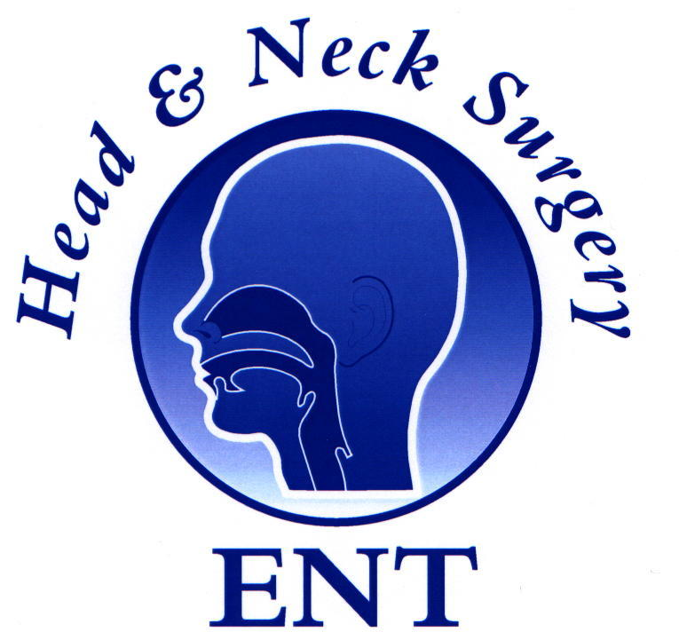

14th Annual National Advanced ENT Emergencies Masterclass®
Friday, 27th June 2025,
Venue: Education Centre, Doncaster Royal Infirmary

08:30 Registration, Tea/Coffee

09:00 Welcome: M S Quraishi, Director, ENT Masterclass®
Head & Neck Emergencies:
09:20 Bindy Sahota Current management of Deep Neck Space Infections. 30 mins
09:50 Beverley Yu Emergencies in the Head & Neck Cancer clinic 30 minutes
10:20 Bindy Sahota Neck Trauma. 40 minutes

11:00 Coffee

Paediatric Emergencies:
11:30 Tawakir Kamani Foreign body, Tonsillectomy bleed, stridor/supraglottitis
etc 30 minutes
12:00 Asad Qayyum Managing Tonsillectomy and Adenoidal Bleeds and Communication in Paediatric Emergencies 30 minutes

12:30 Lunch

Nasal Emergencies:
13:30 Yujay Ramakrishnan Complications of Rhinosinusitis (periorbital cellulitis, subperiosteal abscess, cavernous sinus thrombosis) 30 mins
14:00 Asad Qayyum: Epistaxis ‘beyond’ the packs. 30 minutes
14:30 Yujay Ramakrishnan: Nasal/Ant skullbase Trauma 30 minutes

15:00 Coffee

15:30 Neelam Dugar Role of Radiology in ENT Emergencies 15 minutes (Virtual)
Otological Emergencies:
15:45 Emma Stapleton Complications of ear infections 30 minutes
16:15 Emma Stapleton Acute Facial Nerve Palsy 30 minutes
16:45 Owen Judd Acute Dizziness – is it ever an ENT emergency? 30 minutes

17:15 Final Remarks: M S Quraishi

17:30 Close 4 1+3

FACULTY
Ms Emma Stapleton, (Consultant Otologist, Manchester), Dr Neelum Dugar (Consultant Radiologist, Doncaster), Mr A Qayyum (Consultant ENT Surgeon, Peterborough) Prof M S Quraishi (Consultant ENT Surgeon, Doncaster) Mr Bindy Sahota (Consultant Head and Neck Surgeon, Derby) Ms Tawakir Kamani (ENT Consultant, Nottingham) Mr Yujay Ramakrishnan, (Consultant Rhinologist, Nottingham. Prof Owen Judd, (Consultant ENT surgeon, Derby) Prof Bindy Sahota (Consultant Head and Neck Surgeon, Derby), Miss Beverley Yu (ST8 Sheffield)
8+45+10

